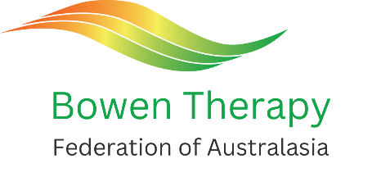
Bowen Therapy Conference 16-18 August 2024
Adelaide Hills Convention Centre, Hahndorf, SA
REGISTRATION FORM
FIRST NAME: | SURNAME:
ADDRESS: | STATE: POSTCODE:
EMAIL: | PHONE:
DO YOU HAVE ANY DIETARY REQUIREMENTS? Y / N (Please provide details)

FULL PAYMENT MUST BE RECEIVED WITH THE SUBMISSION OF THE REGISTRATION FORM.
 | COST | QTY | TOTAL
Early Bird registration (must be paid by Thursday 20th June 2024) | $450
Full price registration (for payments made after 20th June 2024)  *** Please note: After Friday 19th July 2024, no further registration payments will be accepted *** | $495
Single day conference fee (one day only)  SATURDAY 17th or SUNDAY 18^{h} August (tick one box only)  Includes morning, afternoon tea & lunch. Does not include dinner.  Please note: the AGM will take place on Sat 17th August at 3:30pm. | $210
‘Plus One’ Ticket for Saturday Night Gala Dinner  Dinner Partner’s Name: | $75
PAYMENT DETAILS
Direct bank transfer  BTFA bank details:  Acc. name: BTFA  BSB: 033-059  Acc No: 215007  Please advise us of your payment ref. number. | Cash deposit  At any Westpac bank. Please include your surname as reference.  Please attach payment receipt to the registration form when emailing or posting. | Cheque / Money Order  Made payable to: Bowen Therapists Federation of Australia  Your cheque must accompany your registration form. | By Post / Email  Send completed registration form to:  BTFA  PO Box 72  Kilkenny SA 5009  or via email to: btfa-office@bowen.asn.au

