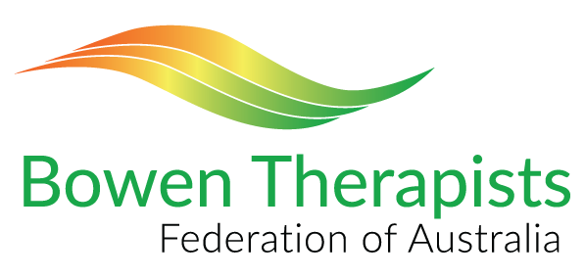
Application for Membership

Please complete this application form and return it via email to btfa-office@bowen.asn.au. No payment is required with this application form; an invoice will be forwarded to you once your application has been processed.
PERSONAL DETAILS

First name | Surname
Date of Birth | Name for Membership Certificate
Mailing Address: Number. & Street | City/ Suburb | Postcode
State | Country (if not Australia)
Phone | Email

CLINIC DETAILS
Clinic 1 name | Clinic phone
Email | Website
Address: No. & Street | City/ Suburb | Postcode
State | Country (if not Australia)
Phone | Email

Clinic 2 name | Clinic phone
Email | Website
Address: No. & Street | City/ Suburb | Postcode
State | Country (if not Australia)
Phone | Email

Clinic 3 name | Clinic phone
Email | Website
Address: No. & Street | City/ Suburb | Postcode
State | Country (if not Australia)
Phone | Email
Please select the level of membership requested:
Membership level (please select one) Fee Documents to be attached
Therapist $200 Refer note 1
Practitioner $200 Refer note 2
Student (1 year only) $20 application fee Refer note 3
Affiliate $120 Refer note 4
Equine or Small Animal Therapist $200 Refer note 5
Equine or Animal Practitioner $200 Refer note 6

Combined Human & Equine/ $220 Refer note 7
Animal Therapist

Note: No payment is required with this application. An invoice will be sent to you when all membership information has been received.

Declaration
I am the applicant named in this document and declare that the details given in this application are
true and correct.
I undertake to comply with the Rules and Bylaws of the BTFA. These include:
- Undertaking to complete the required level of ongoing professional training each year
- Maintaining an appropriate level of professional insurance and Senior First Aid qualification

I agree to my name, business phone number, website and suburb(s) of the clinic(s) where I practice
being listed for referral on the BTFA website.

Signed: …………………………………………………………………. Date: ……………………………………………………….

Print name: ………………………………………………………………………………………………………………………………………....

Attachments required:
Note 1 (Therapist)
- Copy of Diploma in Bowen Therapy from a Registered Training Organisation (RTO) and Statement of Academic Achievement with Units of Competency achieved, certified by a Justice of the Peace (JP).
- Copy of Certificate of Currency for Professional Insurance
If not currently insured, contact our office for details on a recommended insurer. Membership will be finalised when the BTFA receives the Certificate of Currency.
- Copy of Senior First Aid Certificate
If you do not have a current certificate, you must complete a course and obtain one before your membership can be finalised.
- Statutory Declaration (available on BTFA website under ‘Become a Member’) stating that 500 hours of clinical experience has been achieved giving Bowen Therapy treatments, including those required by the Diploma course, and that you have records covering these treatments.

Note 2 (Practitioner)
- Copy of Certificate in Bowen Therapy from a recognised training provider and list of subjects, certified by a Justice of the Peace (JP).
- Copy of certificates for Anatomy and Physiology, covering content in HLTAAP002 ‘Confirm physical health status’ if not included in your Bowen training course.
- Copy of Certificate of Currency for Professional Insurance
- Copy of Senior First Aid Certificate
- Statutory Declaration (available on BTFA website under ‘Become a Member’) stating that 100 hours of clinical experience has been achieved giving Bowen Therapy treatments, including those required by your Bowen training course, and that you have records covering these treatments.

Note 3 (Student)
- Copy of your registration for training in Bowen Therapy from a BTFA-recognised training provider (listed on the BTFA website under ‘Training’).
- Student membership is available for 1 year only and is free, apart from the application fee. After 1 year, Student members must transfer to Affiliate membership (refer Note 4) if not treating clients for Bowen Therapy, or Practitioner membership (refer Note 2).

Note 4 (Affiliate)
Affiliate members must not be treating clients for Bowen Therapy. It is available to people interested in Bowen Therapy, want to support the goals of the BTFA and assist us in increasing awareness of Bowen Therapy as an effective treatment.

Note 5 (Equine Therapist or Small Animal Therapist) - refer to requirements for Therapist (Note 1)
Note 6 (Equine or Animal) - refer to requirements for Practitioner (Note 2)
- Copy of Certificate in Bowen Therapy from a BTFA recognised training provider.
- Copy of Certificate of Currency for Professional Insurance
- Copy of Senior First Aid Certificate
- Statutory Declaration (available on BTFA website under ‘Become a Member’)

Note 7 (Therapist and Equine/Animal (Combined)) - refer to requirements for Therapist (Note 1) and Equine/Animal training (refer Note 6).

