RESEARCH MATTERS – Why are stories and anecdotes important but not enough - The Research hierarchy or pyramid
Hierarchy of research evidence (adapted from http://massagetherapyfoundation.org/wp-content/uploads/Instructors-Guide-to-Teaching-Research-by-Massage-Therapy-Foundation.pdf)
Not all research carries equal weight. Anecdotes and case reports may tell a great story, but they are not rigorously tested on a broad population, and therefore we can’t assume that all clients will have a similar experience to the one being described.
Whilst the individual experiences of therapists are important to share – and can inform the basis of many research questions - conducting research (such as a clinical trial) with lots of clients who are experiencing similar types of symptoms (e.g. back pain) gives us a clearer idea of what a realistic outcome of a therapy for the more general population might be. This is called generalisability. Then, when the results of multiple similar trials about the therapy for back pain are compared, e.g. in a systematic review or meta-analysis, the power of this information is taken to be even greater in credibility and generalisability.
The research pyramid (see Figure 1) represents how evidence quality is considered to move up in both credibility and generalisability. Different versions of the pyramid are available, but the key characteristic of all versions is they move from a broad foundation of individual opinions, stories and reports at the base, to systematic reviews and meta-analyses at the peak.
Having a basic understanding of the research pyramid helps us to critically appraise the credibility and generalisability (quality) of the results of research that we may hear about in seminars or workshops or that may be presented on the internet or in research articles.
Figure 1 – Research Pyramid and quality of evidence
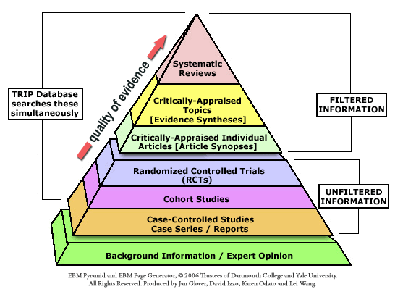
EBM Pyramid and EBM Page Generator, copyright 2006 Trustees of Dartmouth College and Yale University. All Rights Reserved. Produced by Jan Glover, David Izzo, Karen Odato and Lei Wang

